Azure Site Recovery: On-Premise Machine (Physical Server) to Azure
POC: To capture Delay Time in ASR

Case Type : Azure
Case Scenario : Azure Site Recovery configuration using Azure Portal
Create Date : 16th Feburary, 2018
Create By : Garima Anand
Objective : To capture delay in ASR

- Overview
Azure Site Recovery orchestrates and manages disaster recovery for Azure VMs, and on-premises VMs and physical servers. Site Recovery helps ensure business continuity by keeping business apps and workloads running during outages. Site Recovery replicates workloads running on physical and virtual machines (VMs) from a primary site to a secondary location. When an outage occurs at your primary site, you fail over to secondary location, and access apps from there. After the primary location is running again, you can fail back to it.
Site Recovery can manage replication for:

- Azure VMs replicating between Azure regions.
- On-premises VMs and physical servers replicating to Azure, or to a secondary site.
- VMs from other cloud providers, say AWS, replicating to Azure.
Using Site Recovery, you can set up and manage replication, failover, and failback from a single location in the Azure portal. You can set up disaster recovery of Azure VMs from a primary region to a secondary region. You can replicate on-premises VMs and physical servers to Azure, or to a secondary on-premises datacenter. Replication to Azure eliminates the cost and complexity of maintaining a secondary datacenter.
The Azure Site Recovery service contributes to your business continuity and disaster recovery (BCDR) strategy by keeping your business apps up and running during planned and unplanned outages. Site Recovery manages and orchestrates disaster recovery of on-premises machines and Azure virtual machines (VMs), including replication, failover, and recovery.

- Physical to Azure replication architecture
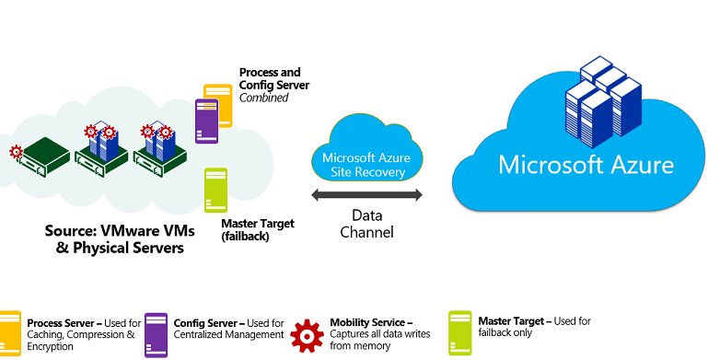
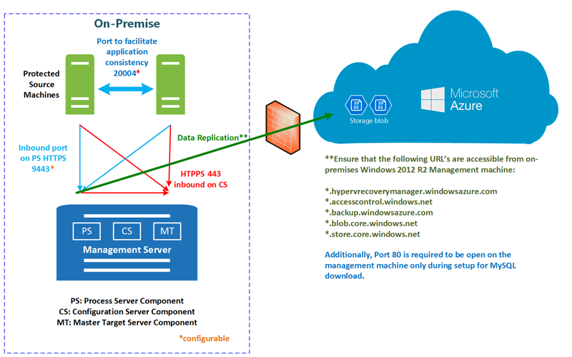
Fig: Replication process

- Procedure to capture delay in Azure Site Recovery

In this POC, we follow below mentioned steps to capture the delay:

- Insert some real-time values in SQL database. It should keep on inserting the values continuously.
- Then, test failover the on-premise m machine to Azure.
- After certain time, power off your on-premise machine. Make sure you note the time when you shut down the machine.
- Connect to the replicated machine on Azure and recover the SQL database using recovery file.
- Note down the timestamp value which shows the time of the last updated value in the database.
- Compare this timestamp value with the time when you shut down the physical machine. That difference in time gives the delay in ASR.

- Pre-Requisite for ASR (Physical to Azure)

- Prepare Azure:

Create a Resource Group and create all the below mentioned resources in that Resource Group.
- Storage Account
- Recovery Services Vault
- Virtual Network

- Create Storage Account

Images of replicated machines are held in Azure storage. Azure VMs are created from the storage when you fail over from on-premises to Azure.
- In the Azure portal menu, click New > Storage > Storage account.
- In Create storage account, enter a name for the account. The name must be unique within Azure, and be between 3 and 24 characters, with numbers and lowercase letters only.
- Use the Resource Manager deployment model.
- Select General purpose > Standard. Don't select blob storage.
- Select the default RA-GRS for storage redundancy.
- Select the subscription in which you want to create the new storage account.
- Select the geographic location for your storage account same as that of Resource Group as the storage account must be in the same region as the Recovery Services vault.
- Click Create to create the Storage Account.

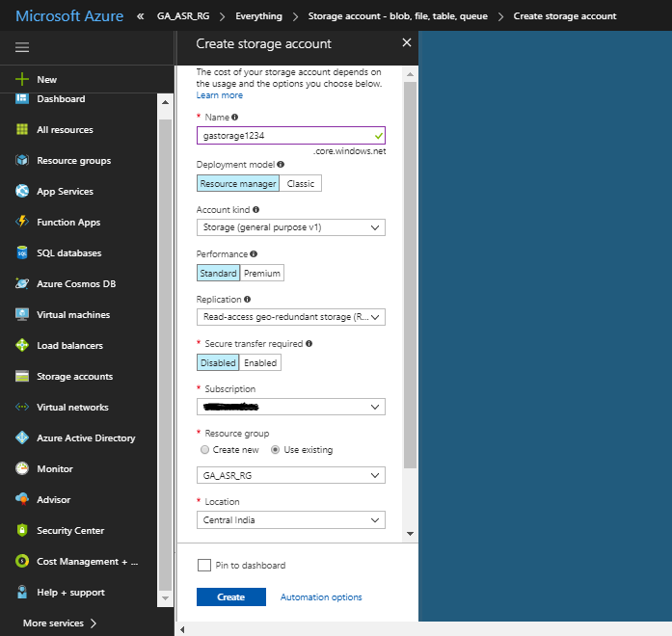

- Create Recovery Services Vault

- In the Azure portal menu, click New > Monitoring & Management > Backup and Site Recovery.
- In Name, specify a name to identify the vault.
- Select the existing Resource Group.
- Specify the Azure Region same as that of Resource Group. Recovery Services vault must be in the same region as the storage account.
- Click Create to create the Recovery Services Vault.
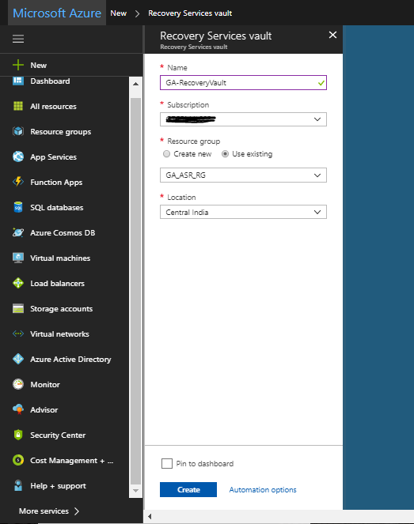

- Virtual Network
When Azure VMs are created from storage after failover, they're joined to this network.
- In the Azure portal menu, click New > Networking > Virtual network
- Leave Resource Manager selected as the deployment model. Resource Manager is the preferred deployment model.
- Specify a network name. The name must be unique within the Azure resource group.
- Use the existing Resource Group.
- Specify the network address range, in my case, it is 10.4.0.0/24.
- We don't need a subnet.
- Select the subscription in which to create the network.
- Select the location same as that of Resource Group. The network must be in the same region as the Recovery Services vault.
- Click Create.

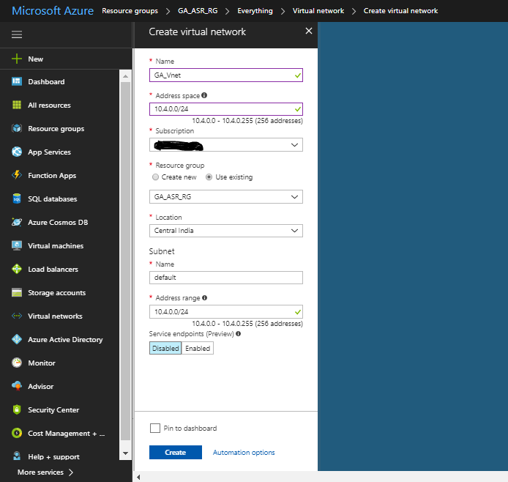

- Prepare On-Premises Physical Machine:

- Require minimum 2 physical Servers. One physical server would serve as configuration server. Other physical server(s) as the machines you want to protect on Azure.
- Server operation System on the physical machine should be Windows Server 2012 R2 or above.
- Machine should have a stable internet connectivity. Machine should have access to all Azure Regions.
- Remote Desktop should be enabled on the physical servers which you are protecting.

- Requirement to capture delay in ASR:

Install following softwares on Physical machine which we want to protect: -
- Install SQL Server,
- Install SQL Server Management Studio (SSMS)

- Set up Azure Site Recovery of Physical Machine to Azure

In All Services > Recovery Services vaults, click the name of the vault we have prepared. In Getting Started, click Site Recovery. Then click Prepare Infrastructure.

- Select a Protection Goal

- Where are your machines located, select on – premises.
- In Where do you want to replicate your machines, select To Azure.
- In Are your machines virtualized, select Not Virtualized/Other.
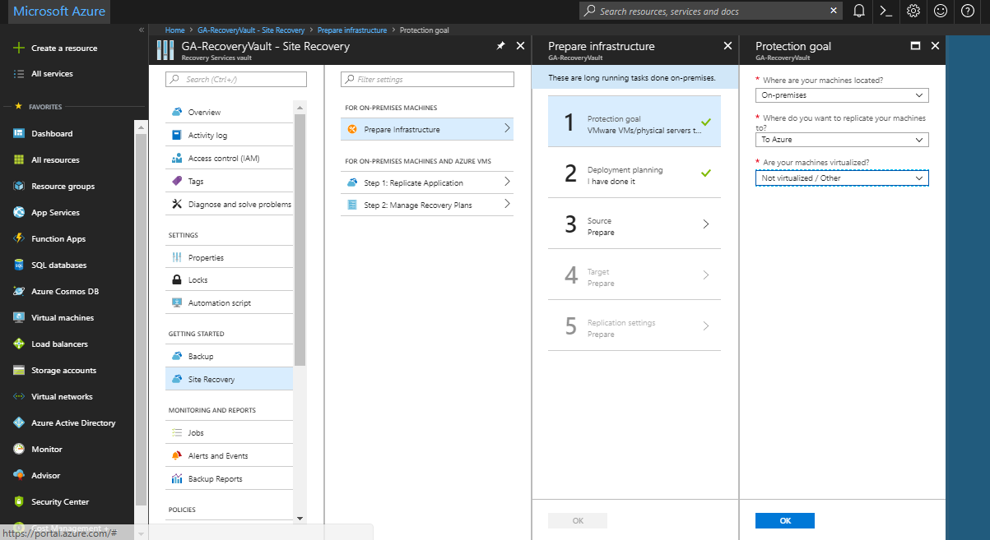

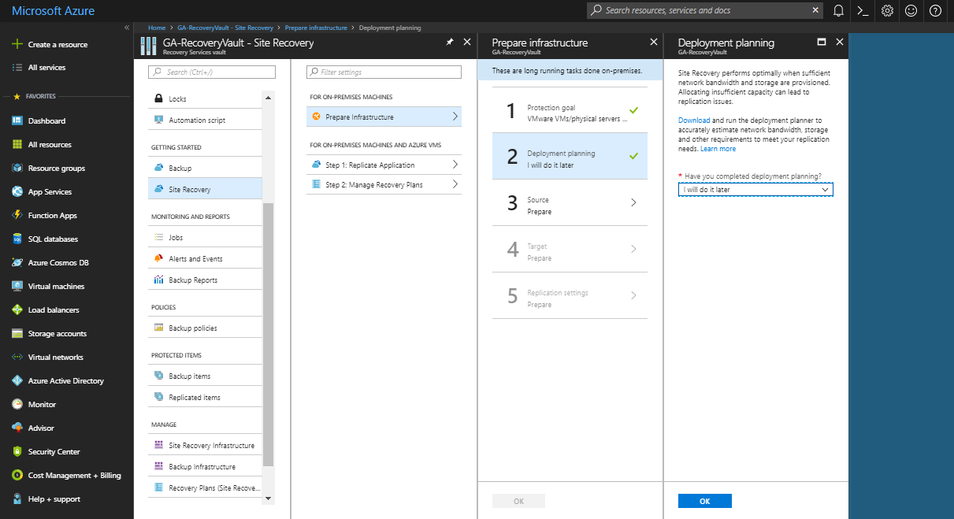

Set up the source environment

Set up the configuration server, register it in the vault, and discover VMs.
- In Prepare Infrastructure, click Source.
- If you don’t have a configuration server, click +Configuration server.
- In Add Server, check that Configuration Server appears in Server type.
- Download the Site Recovery Unified Setup installation file.
- Download the vault registration key. You need this when you run Unified Setup. The key is valid for five days after you generate it.
- Run the Site Recovery Unified Setup file on the Configuration server.
- Provide vault registration key to register the server.
- Once the server is registered, the Configuration server is displayed on the portal.

Installing the Microsoft Azure Site Recovery Unified Setup: -

- Run Microsoft Azure Site Recovery Unified Setup software. Click on Next.

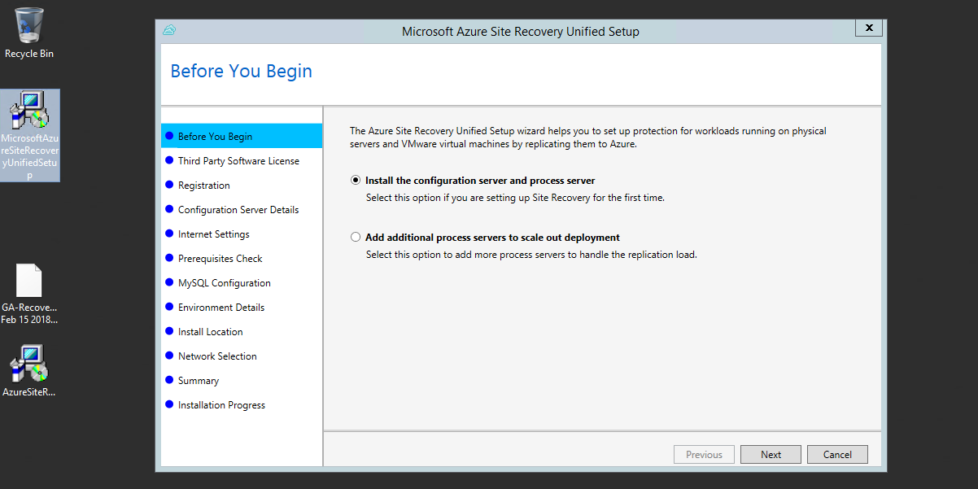

- Accept the software license agreement and click on Next.

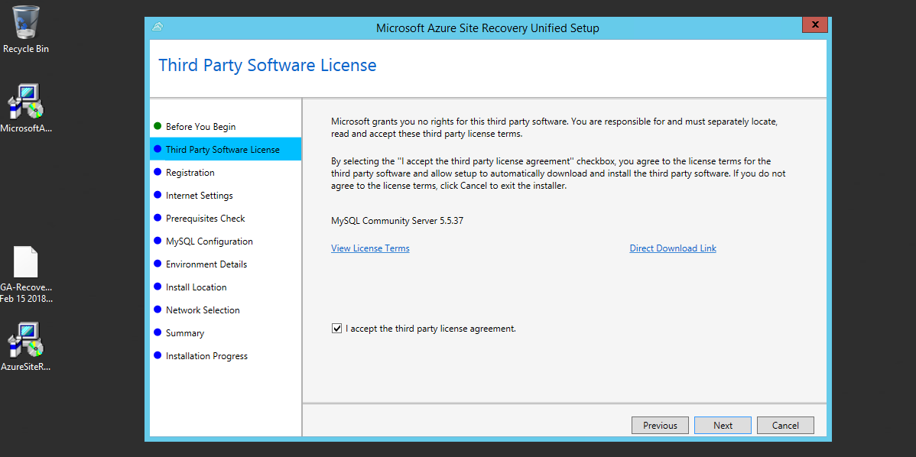

- Browse the site recovery vault registration key which you have downloaded from Azure and click on Next.

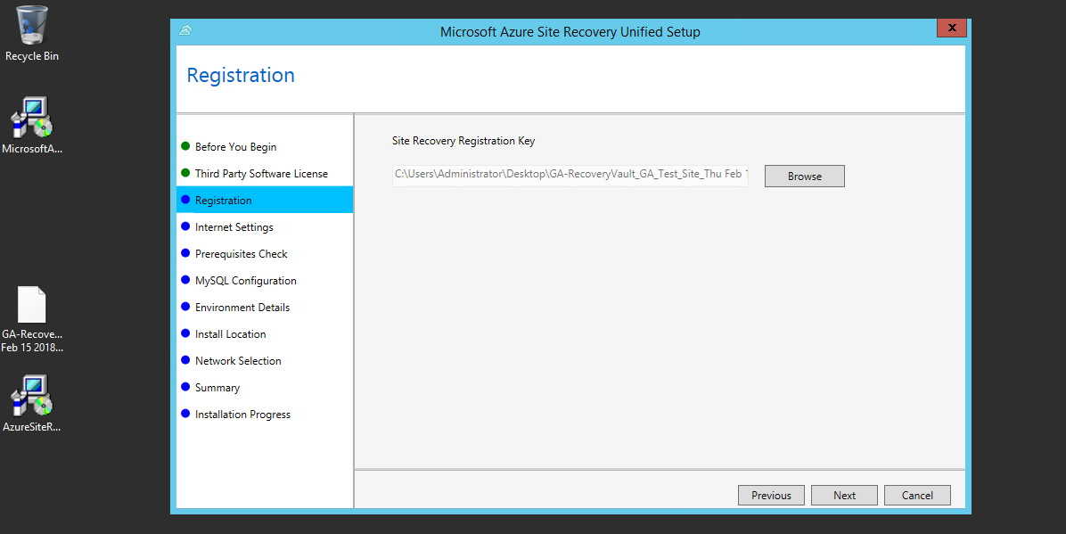

- Connect to the ASR without using proxy server and click on Next.

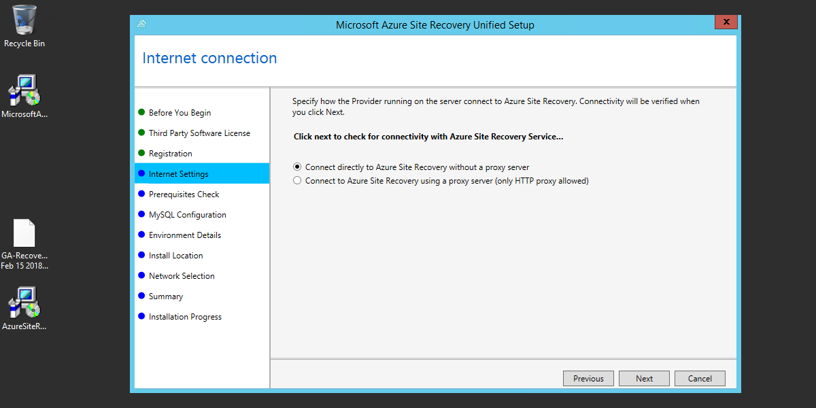

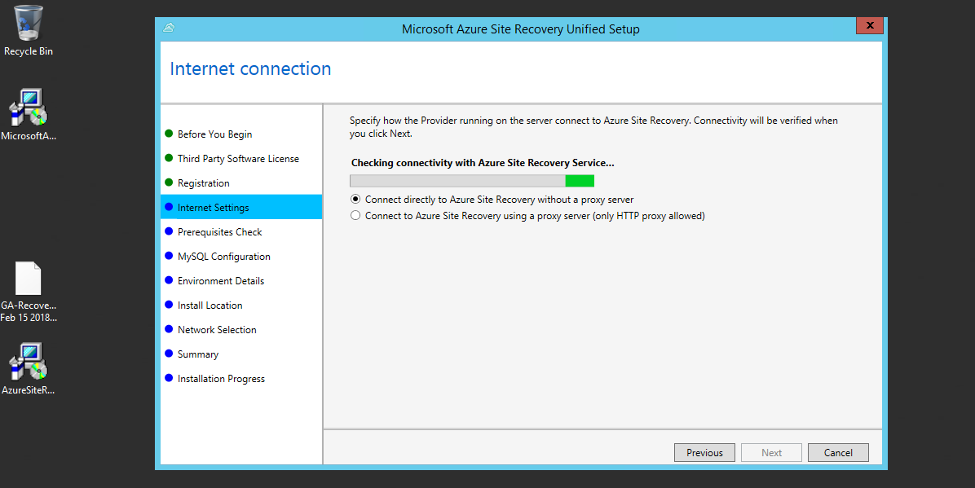

- It will run the prerequisite check on Hyper-V Server. Status of the tests shouldn’t be “Failed”. Status should be either “Passed” or “Warning”. Ignore the warnings and click on Next.

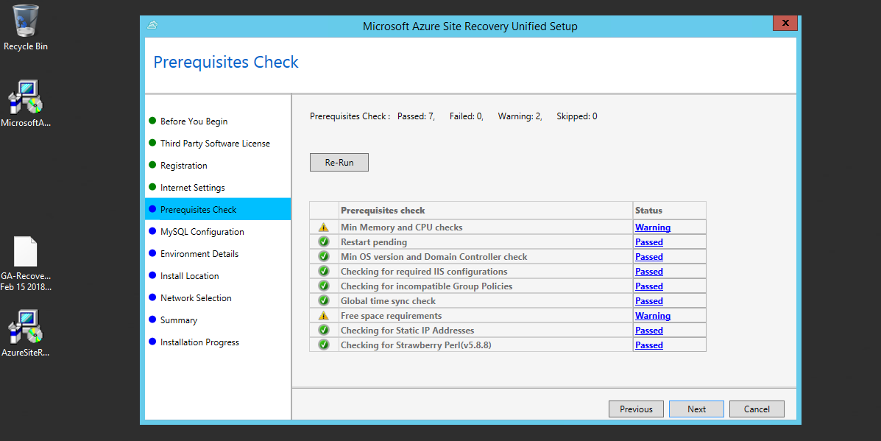

- Enter a new password for MySQL and click on Next.

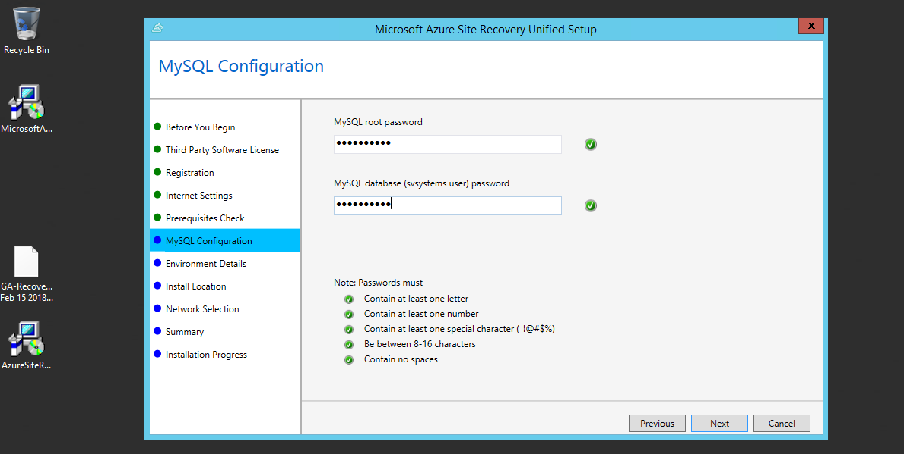

- For this POC, we are using only Hyper-V VMs. So, Select No and click on Next.

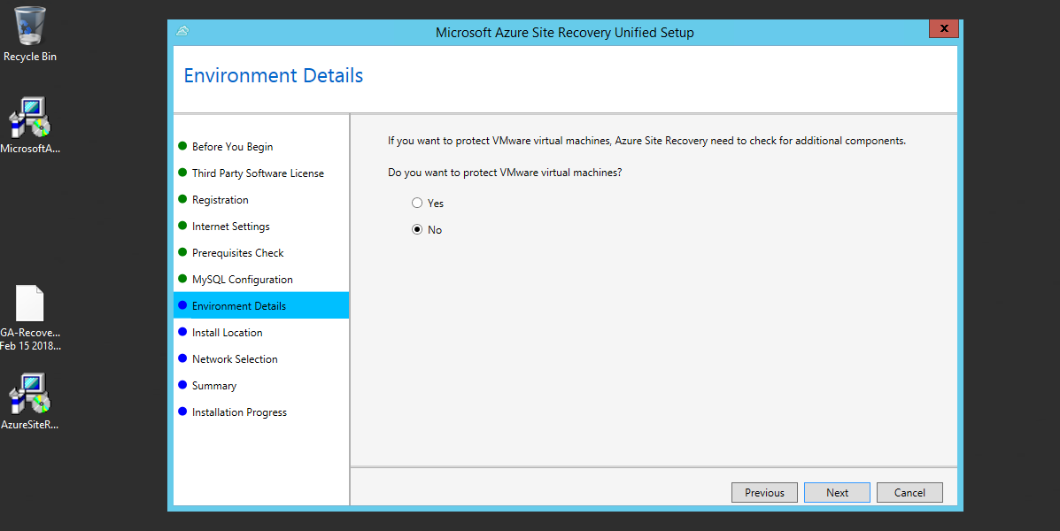

- If you want any other installation location, click on browse and select the location. Else, go with the default location and click on next.

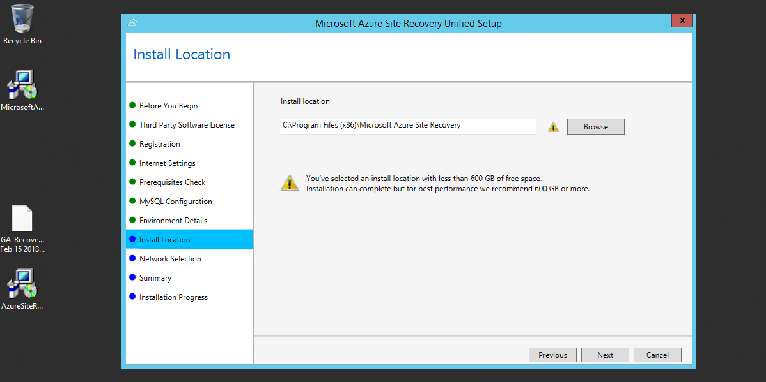

- No Change on this step. Click on Next.

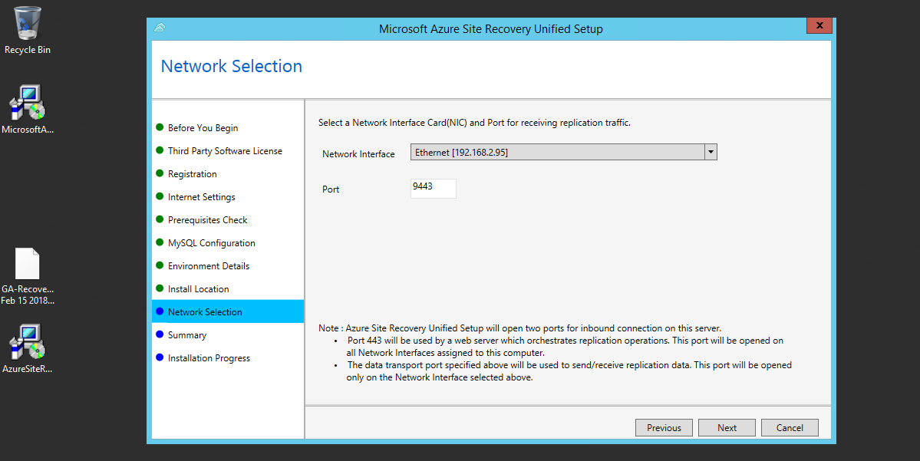

- Click on Install.

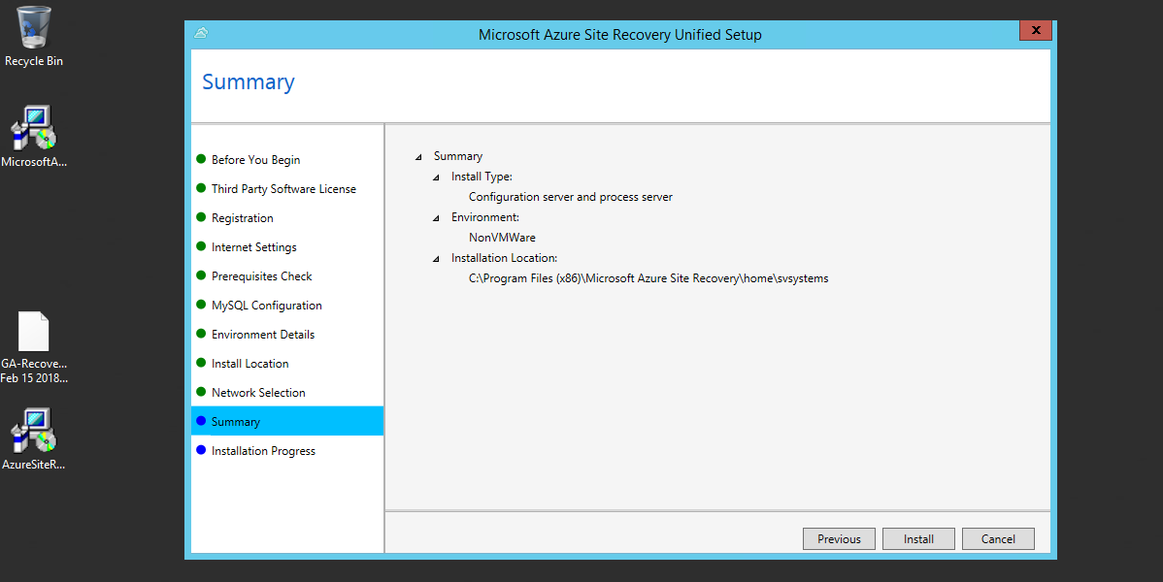

- It will install all the software mentioned in the list.

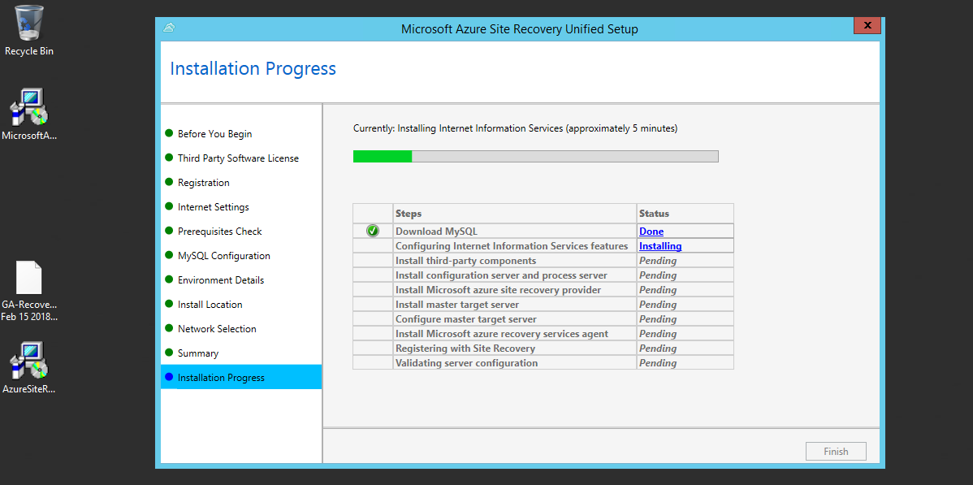

- Once all the software gets installed. Click on Finish.

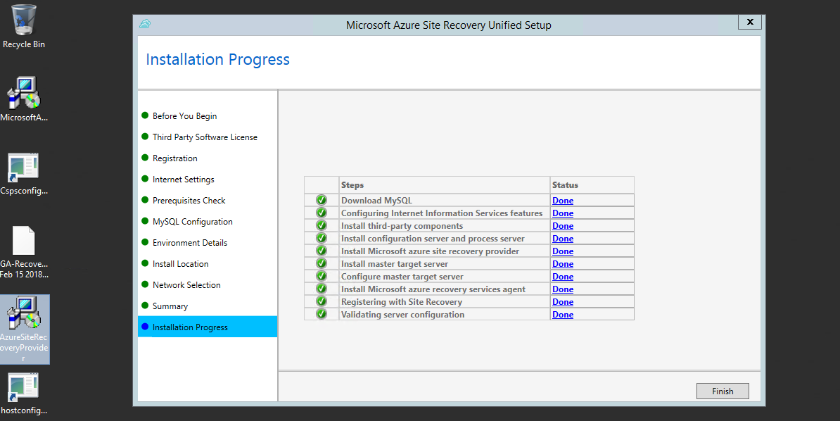

- A new window Pops-up. Click on Manage Accounts and enter the Machine details like machine username and password.
- Click on vault registration. Browse for vault registration key and click on Register
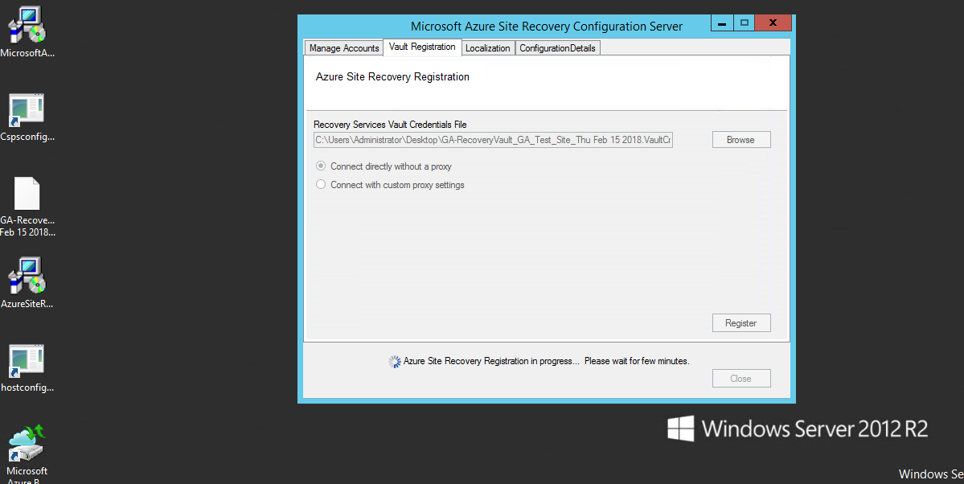

- Once registration is completed, gets message “DRA registration is completed”. Restart the machine (Hyper-V Server).

On Azure portal, Configuration Server will be populated. Click on OK.
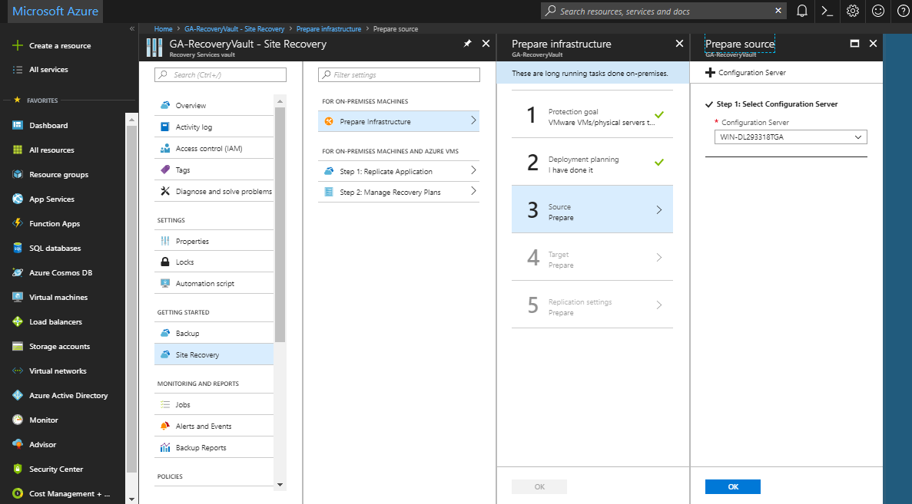

Set up the Target environment

Select and verify target resources.
- In Prepare infrastructure, click Target.
- Select the subscription and the resource group in which the Azure VMs will be created after failover.
- Select the Resource Manager deployment model.
Site Recovery checks that you have one or more compatible Azure storage accounts and networks. If all the 3 steps have green check mark. Click OK.

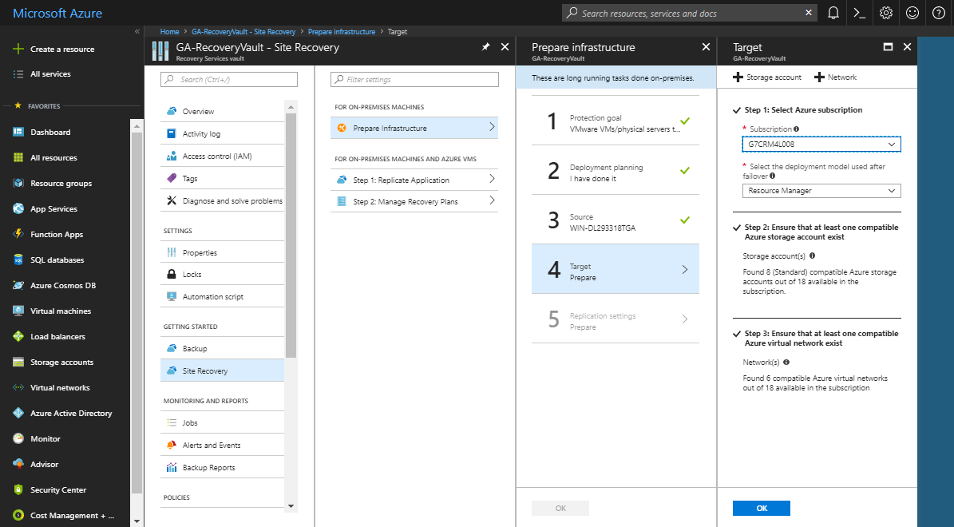

Set up the replication policy
- To create a new replication policy, click Replication Policies and click on Create and Associate.
- In Create and Associate policy, specify a policy name.
- In RPO threshold, specify the recovery point objective (RPO) limit. This value specifies how often data recovery points are created. An alert is generated if continuous replication exceeds this limit.
- In Recovery point retention, specify how long (in hours) the retention window is for each recovery point. Replicated VMs can be recovered to any point in a window. Up to 24 hours retention is supported for machines replicated to premium storage, and 72 hours for standard storage.
- In App-consistent snapshot frequency, specify how often (in minutes) recovery points containing application-consistent snapshots will be created. Click OK to create the policy.
- Leave the default settings and click OK.
- The policy is automatically associated with the configuration server.
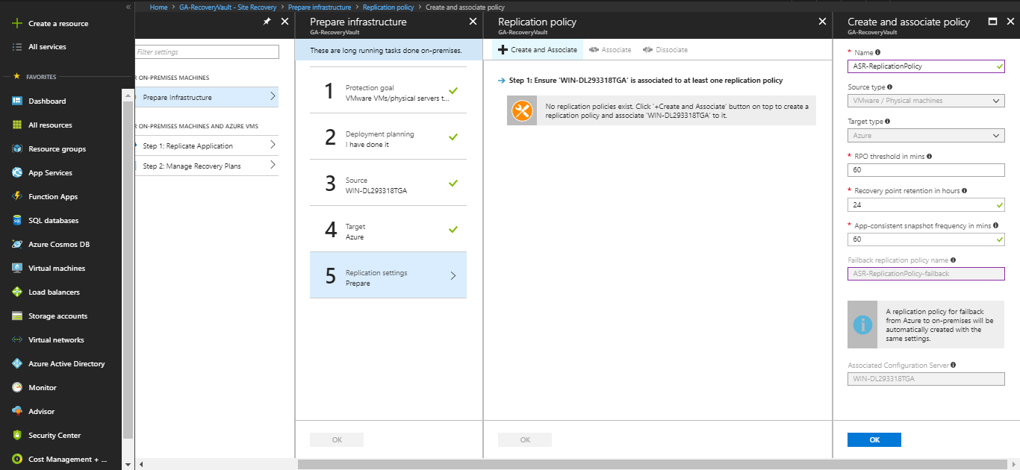

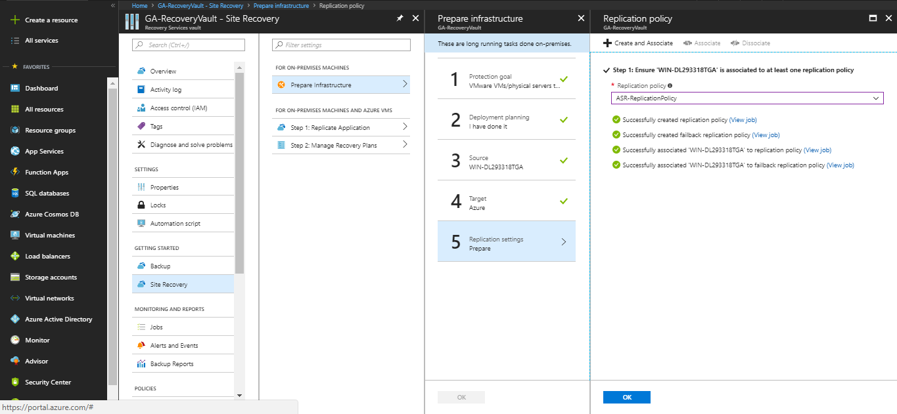
Once all the steps to prepare infrastructure are completed, click on OK.
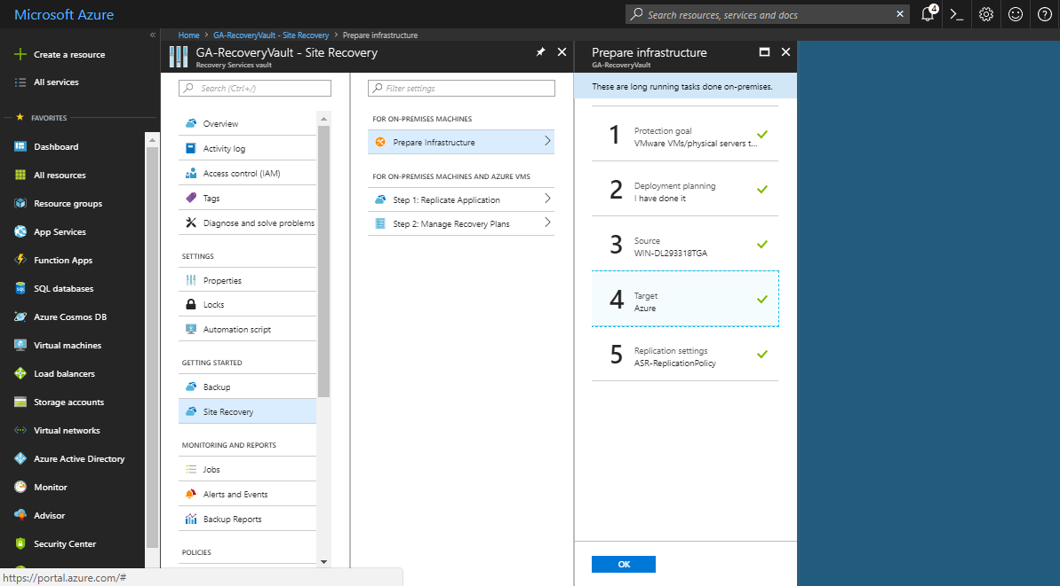

Enable replication
Enable replication for each server.
- Site Recovery will install the Mobility service when replication is enabled.
- When you enable replication for a server, it can take 15 minutes or longer for changes to take effect, and appear in the portal.
- Click Replicate application > Source.
- In Source, select the configuration server.
- In Machine type, select Physical machines.
- Select the process server (the configuration server). Then click OK.
- In Target, select the subscription and the resource group in which you want to create the Azure VMs after failover. Choose the deployment model that you want to use in Azure (classic or resource management).
- Select the Azure storage account you want to use for replicating data.
- Select the Azure network and subnet to which Azure VMs will connect, when they're created after failover.
- Select Configure now for selected machines, to apply the network setting to all machines you select for protection. Select Configure later to select the Azure network per machine.
- In Physical Machines, and click +Physical machine. Specify the name and IP address. Select
the operating system of the machine you want to replicate. It takes a few minutes for the servers to be discovered and listed.
- In Properties > Configure properties, select the account that will be used by the process server to automatically install the Mobility service on the machine.
- In Replication settings > Configure replication settings, verify that the correct replication policy is selected.
- Click Enable Replication. You can track progress of the Enable Protection job in Settings > Jobs > Site Recovery Jobs. After the Finalize Protection job runs the machine is ready for failover.
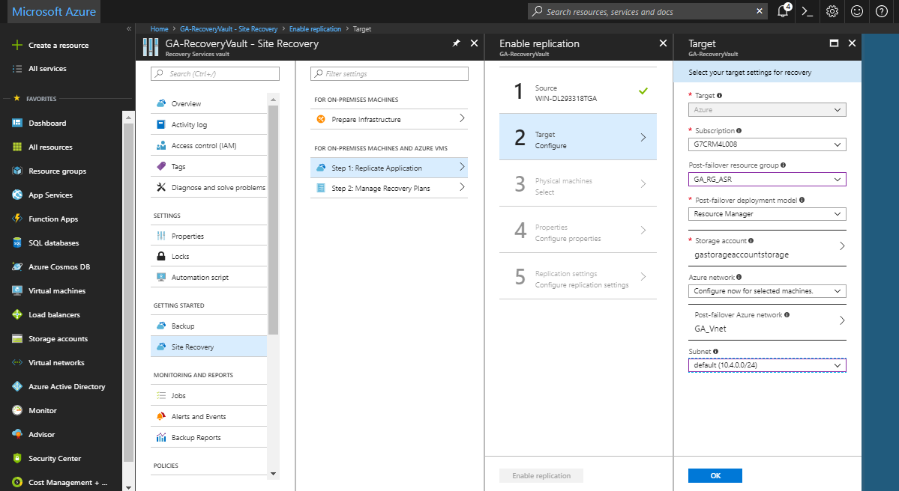
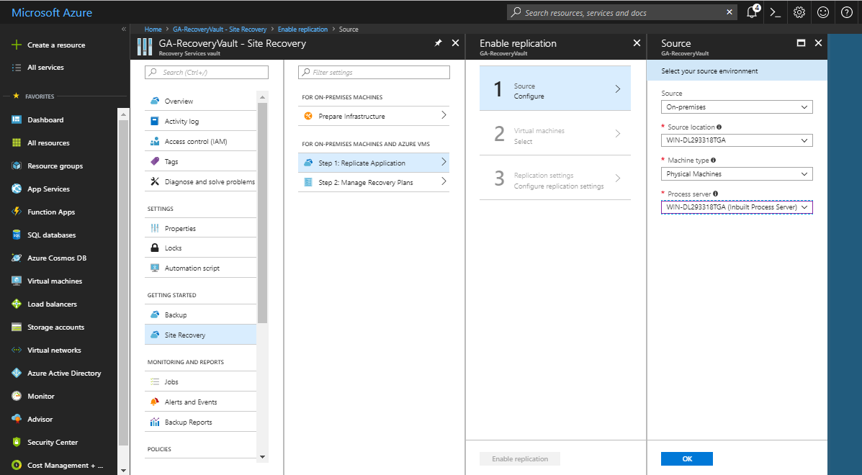
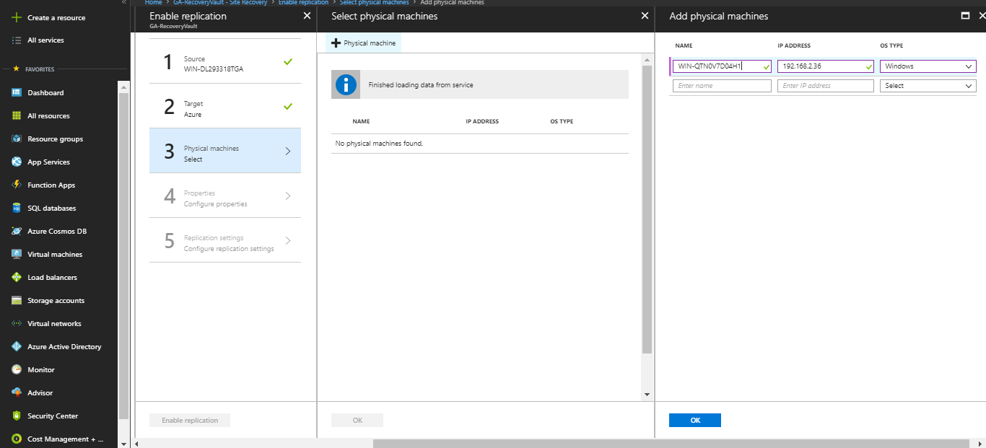

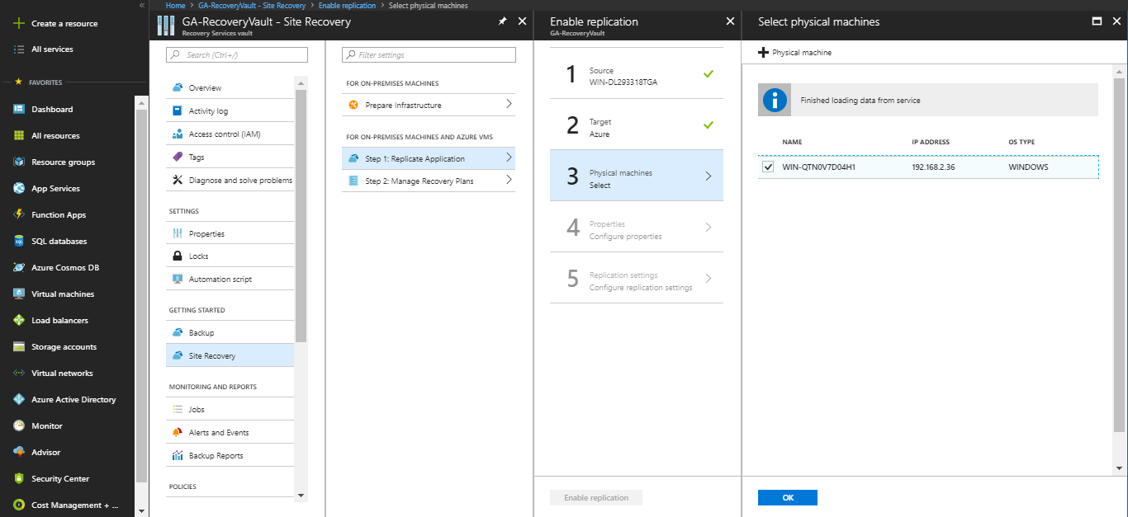

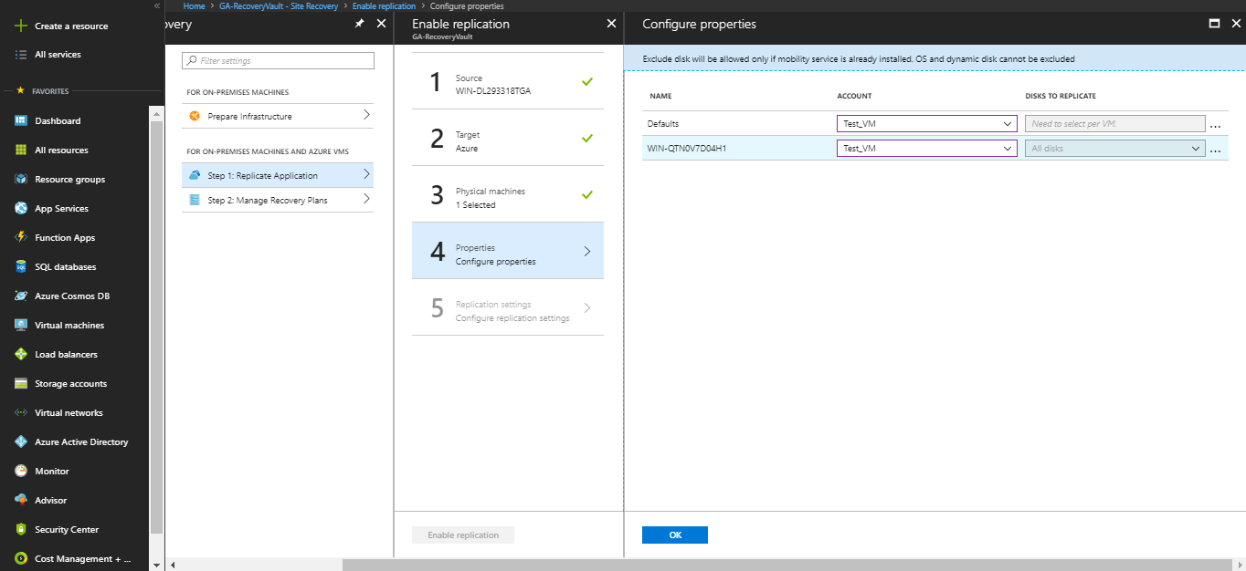

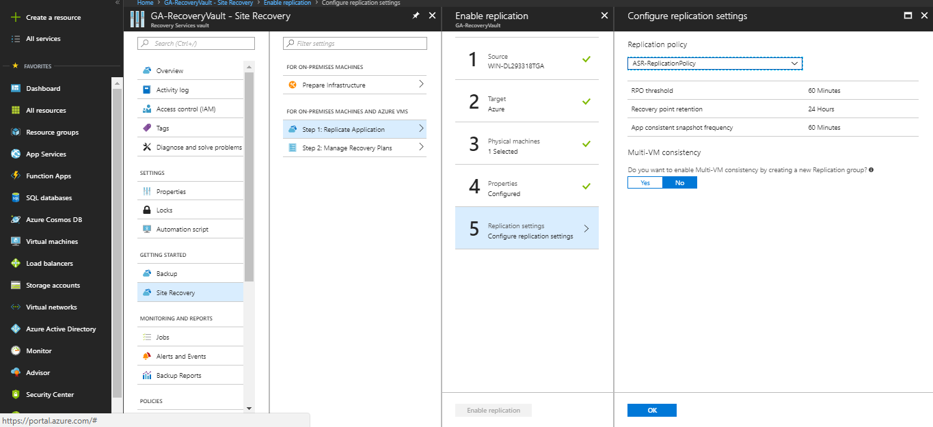

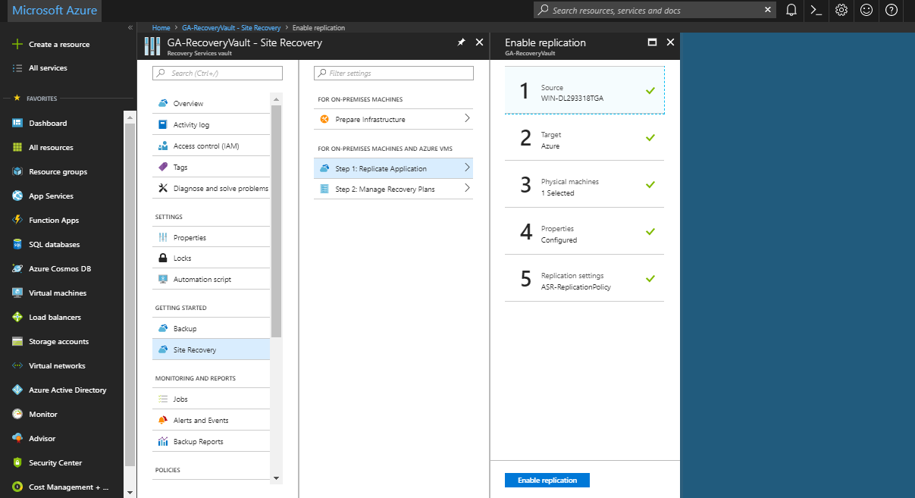

Manage Recovery Plans
- In Recovery plan tab, click on + Recovery Plan to create a new recovery plan.
- Specify name for the recovery plan, select your source machine and target should be Microsoft Azure.
- Select Resource Manager as deployment model.
- Click on select items. Select the machine which you want to protect. Click on OK.
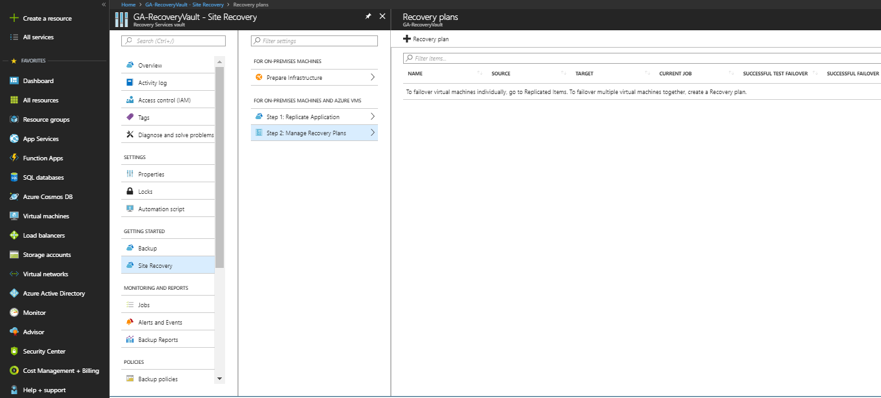
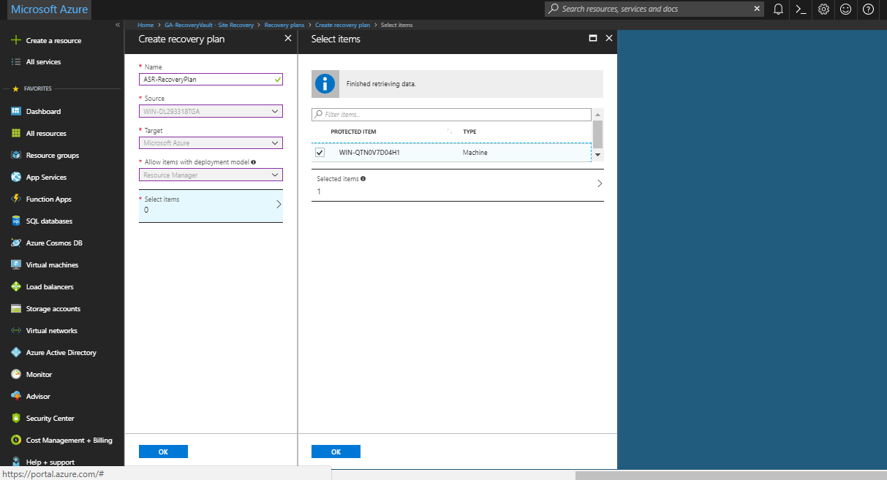

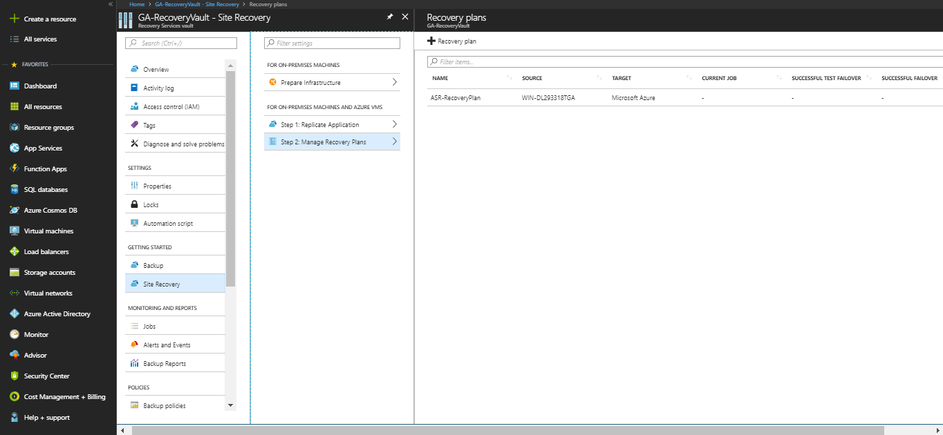

In settings, go to Protected Items, click on Replicated Items. Here, you can check the status of the machine you have replicated. The status will change to “Protected” once the synchronization of on-premise machine to Azure gets completed. Replication health should always be “Healthy”.
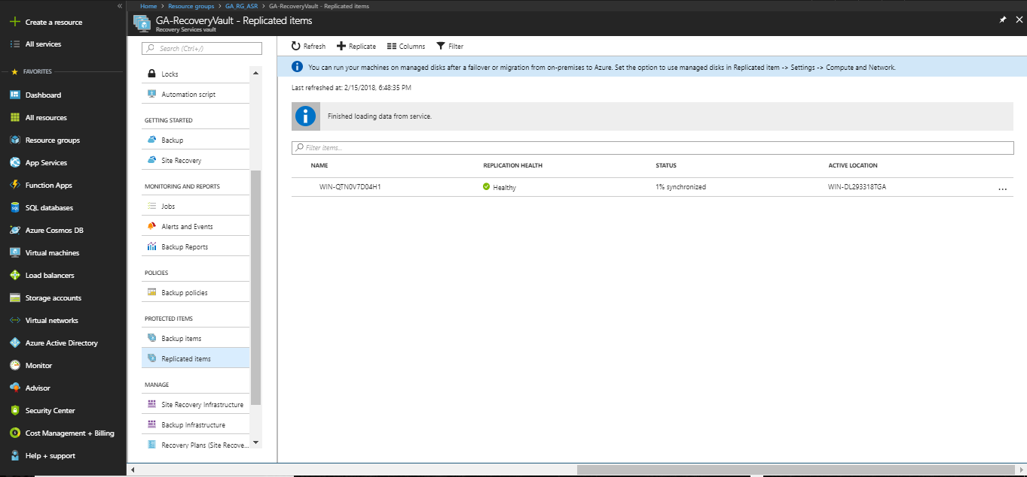

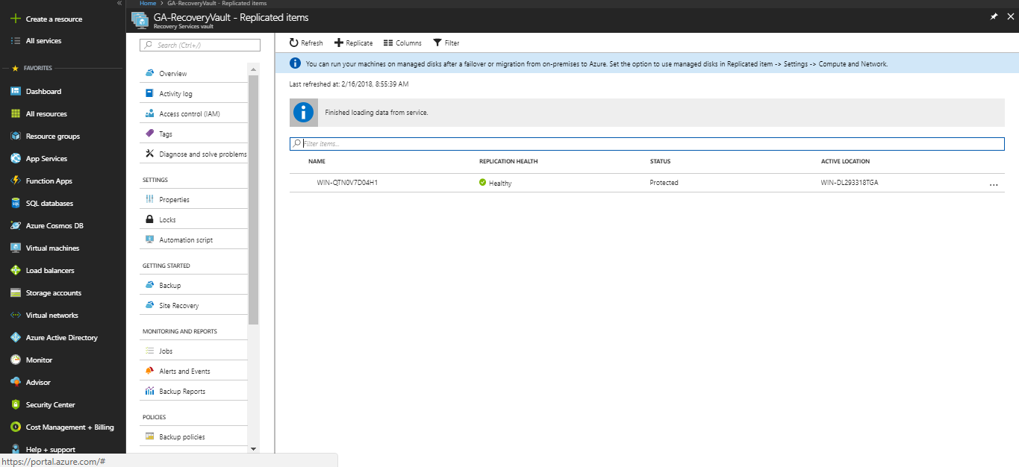
- Setup to capture the delay in ASR

- On the physical machine, which you want to protect, open SQL Server Management Studio.
- Create a database in SQL Server Management Studio.

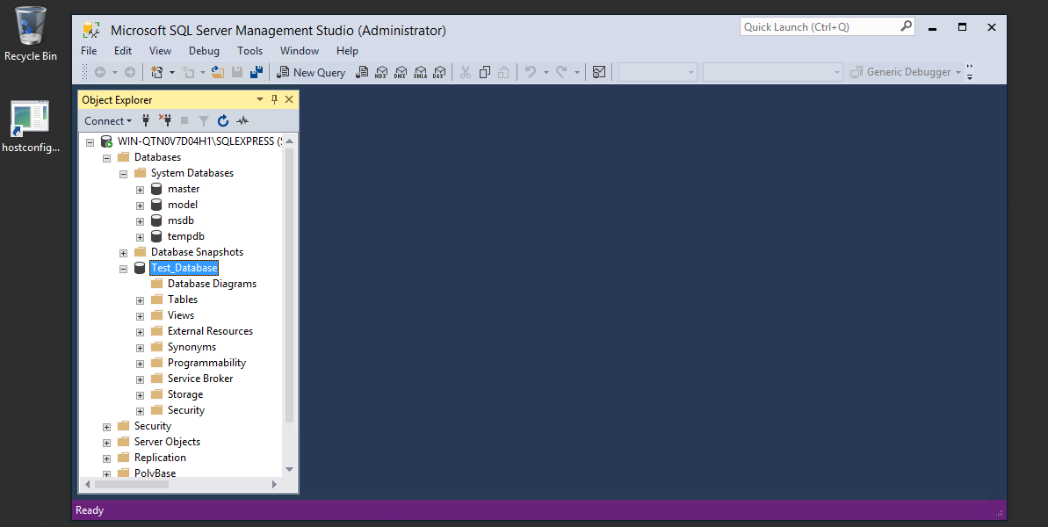

- Click on “New Query” on top. Run following query to create table in your database.
Click on Execute.
--Create Table
create table sqlpass (SNo int identity(1,1),RandomNumber varchar(50),SavevdTimestamp varchar(100))
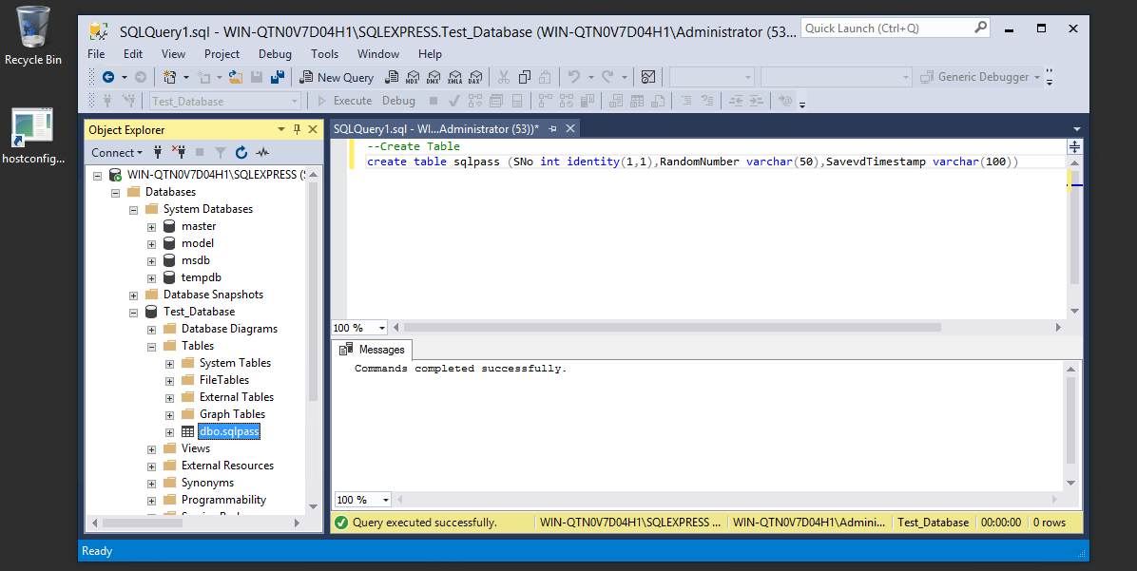

- Run following query to Insert sample data in the SQL table. Click on Execute.

--Insert sample Data

while(1=1)
begin
insert into sqlpass values (newID(),SYSDATETIMEOFFSET())

waitfor delay '00:00:10'
End
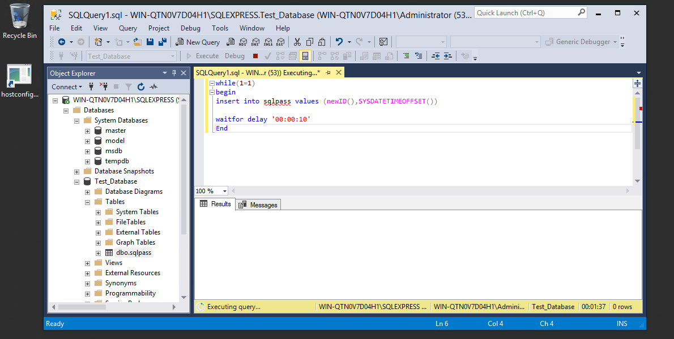

- Perform test failover of the relicated physical machine.

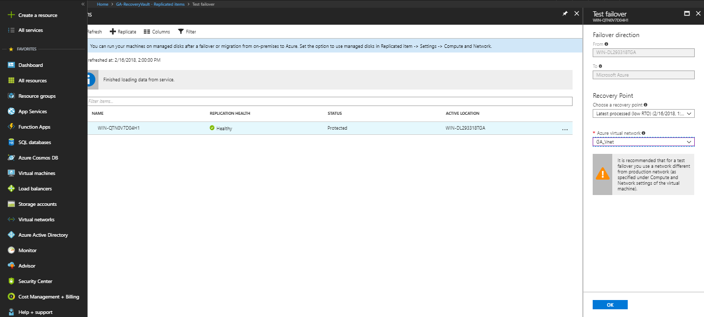

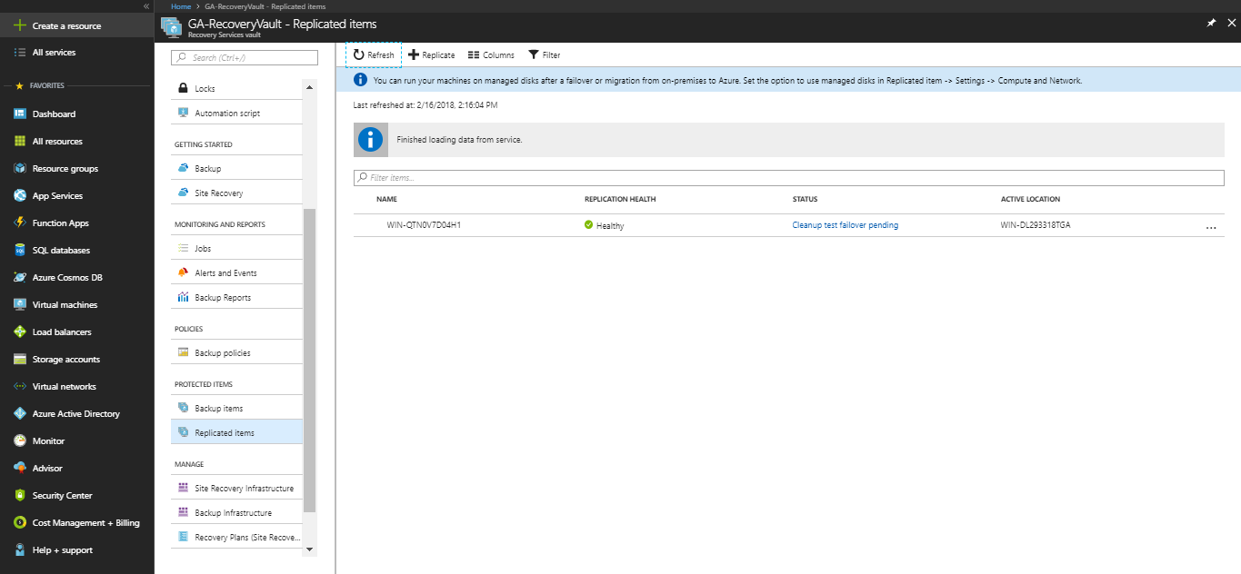

- Note the time and then shut down the physical machine. In my POC, I shutdown my machine at 17:30.
- On Azure, Connect to the Replicated Virtual Machine.

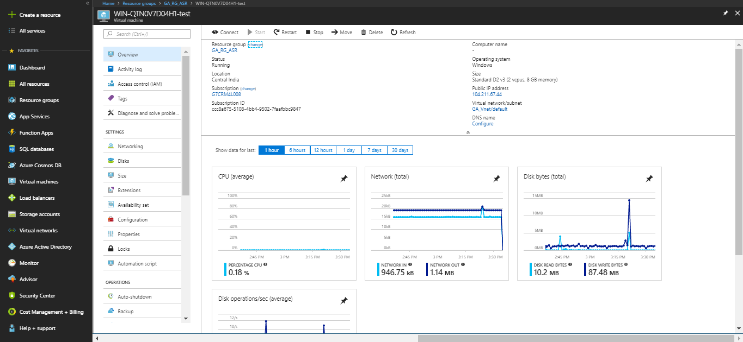

- Recover the SQL database recovey file.

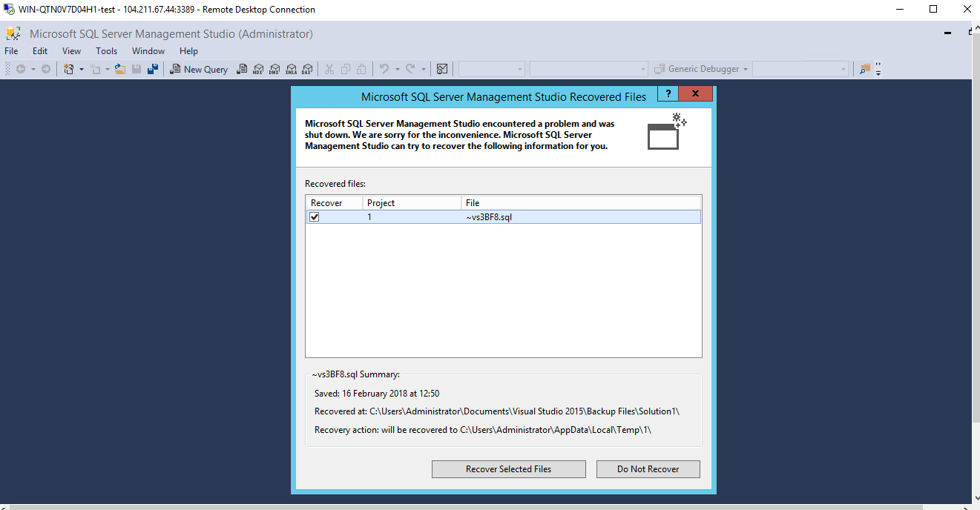

- Run the following select query to select the values from database and to check the timestamp of last updated value. Click on Execute.

--Select Table records

select * from sqlpass

- Check the message. Note the timestamp value. In my POC, the timestamp value I got is 15:30. So, 17:30-15:30 = 2:00 mins.
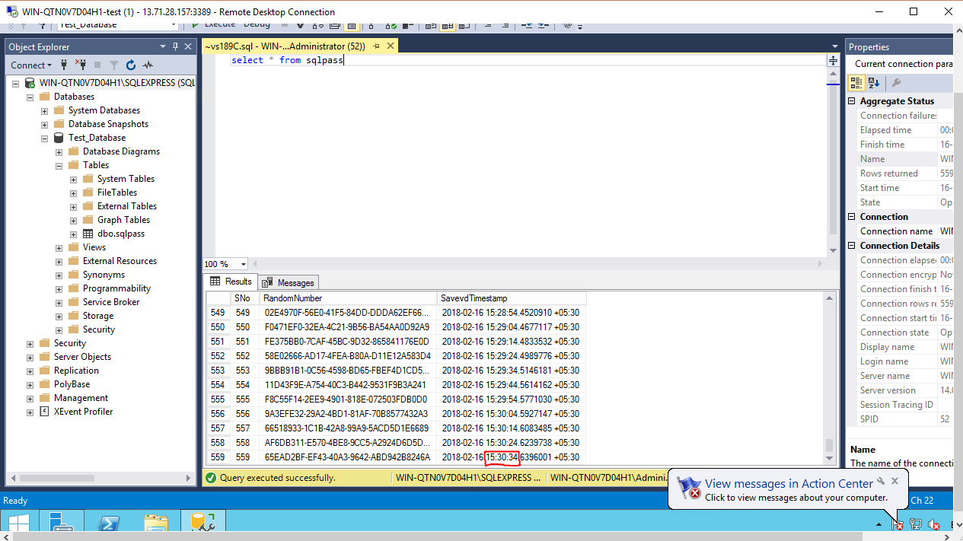

- Conclusion

Captured the delay in ASR. When values are being inserted on physical machine in real time basis (which is already replicated to Azure), experienced some delay in timestamp value on the replicated virtual machine (on Azure). Delay time captured, in this POC, it is 2 mins.
Data/Value updated last on “On-Premise Machine” (Time): 17:30
Data/Value updated last on “Azure Virtual Machine” (Time ): 15:30
Delay in Timestamp Value: 2:00 mins

